Requirement Analysis
Data Flow Diagram & User Stories
Date | 30 September 2026
Project Name | Script-Controlled ACL – Restrict Record Access Based on Field Value
Maximum Marks | 3 Marks

Data Flow Diagrams:
A Data Flow Diagram (DFD) is a traditional visual representation of the information flows within a system. A neat and clear DFD can depict the right amount of the system requirement graphically. It shows how data enters and leaves the system, what changes the information, and where data is stored.
For this project, the DFD represents the flow between the user, ServiceNow ACL security layer, Institution Details table, and administrator. Users submit requests to access records, the ACL evaluates the user's role and Branch condition, and the system allows or denies the requested operation.
[DFD: User → ServiceNow ACL → Institution Details Table → Access Granted / Access Denied]

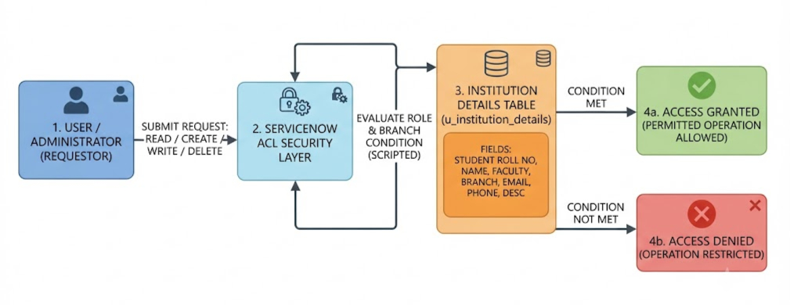

User Stories
Use the below template to list all the user stories for the product.

User Type | Functional Requirement  (Epic) | User Story  Number | User Story / Task | Acceptance criteria | Priority | Release
Administrator | User & Role Management | USN-1 | As an administrator, I can create users and assign appropriate roles so that users receive the required access. | I can create users and assign roles such as bb1, bb2, bb3 and bb4. | High | Sprint-1
Administrator | Table Management | USN-2 | As an administrator, I can create the Institution Details table and add the required fields. | I can create u_institution_details with Student Roll Number, Student Name, Faculty Name, Branch, Email, Phone Number and Description. | High | Sprint-1
Authorized User | Read Access | USN-3 | As an authorized user, I can view records when I satisfy the required ACL role and Branch condition. | A user with the required role can view the permitted EEE branch records. | High | Sprint-1
Unauthorized User | Read Access | USN-4 | As an unauthorized user, I cannot view records when I do not have the required role. | A user without the required role cannot view the restricted records. | High | Sprint-1
Authorized User | Create Access | USN-5 | As an authorized user, I can create a new record when I have the required create permission. | A user with the required create role can use the New button and create a record. | High | Sprint-2
Authorized User | Write Access | USN-6 | As an authorized user, I can edit records when I have the required write permission. | A user with the required write role can view and edit permitted records. | High | Sprint-2
Authorized User | Delete Access | USN-7 | As an authorized user, I can delete records when I have the required delete permission. | A user with the required delete role can delete permitted records. | Medium | Sprint-2
Administrator | Full Access | USN-8 | As an administrator, I can view and manage all records regardless of Branch. | Administrator can view all records and perform the permitted operations. | High | Sprint-2

